the reverend DONALD WALLACE
(1925 – 2018)

D
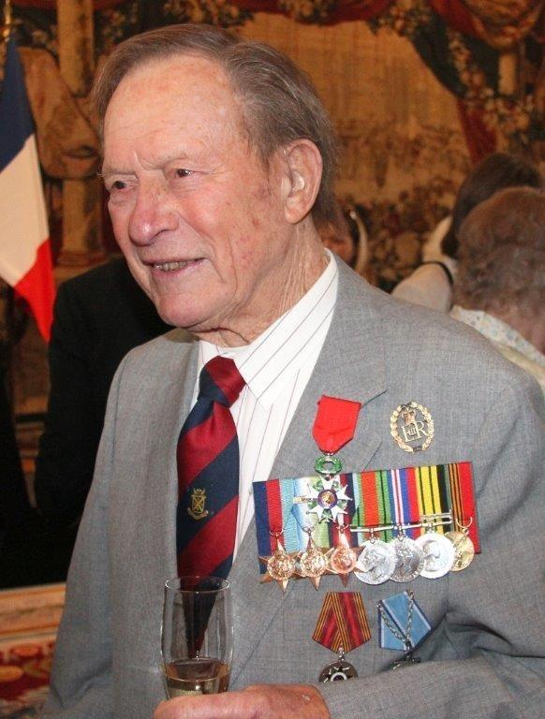
onald Wallace was 92 when he died. This is all the more remarkable as his death was the result of an accident while he was riding his motorcycle! He was a Church of Scotland minister becoming a minister after he had seen service on the Russian convoys during the Second World War. He has been described as a colourful Chaplain whose presence was not easy to ignore. Ray Hubble remembers meeting him at RAF El Aden in Libya when Donald was attached to a SAS desert patrol. By the early 1970s he had become an Assistant Principal Chaplain CSFC (in the days when such a position existed) and Robin Turner remembers him visiting RAF Waddington when Robin was Chaplain there. In addition to his service in the Branch he had a reputation for his addresses over 30 years at Scottish Bankers' Burns Nights. He was also for many years Chaplain to the De Havilland Moth Association and Chairman of Governors of Parmiter School where there is a portrait of him in clerical robes with a RAF Chaplain's scarf. He had a son who lives in Australia, and a daughter, Fiona. His wife, Betty, survives him. Noel James’ widow, Mollie, wrote the following : “Perhaps you could ask anyone who knew Donald if ‘beep beep, bubble car, bubble car, biscuit biscuit’ means any thing to them. Memories of his visit to Hong Kong! “

Donald’s obituary read as follows :

The Reverend Group Captain Donald Wallace , who has died aged 92, served in the
Royal Navy during the Second World War and was later ordained and had a long
career in the RAF; he was appointed an honorary chaplain to the Queen in 1977.
Born on September 5 1925 in Edinburgh, he attended schools in the city before joining
the Navy as soon as possible in 1943, training as an Asdic operator.

Wallace served in the destroyer Hotspur during the Battle of the Atlantic before
transferring to the frigate Essington. After a period on anti-submarine duties in the
Southwest Approaches, the frigate joined the 3rd Escort Group to support the Allied
landings in Normandy, during which period it was involved in the sinking of the
German U-boat U-988 west of Guernsey. In October 1944 it was assigned to escort the
Arctic convoys, sailing from Loch Ewe to Murmansk and the Kola Peninsula. Wallace
left the Navy as an able seaman in 1946.

After the war he read Theology at St Andrews University before joining the RAF as a
Presbyterian chaplain in January 1951. He was posted to Aden, where his wide-flung
parish covered much of the Middle East. It also took in Kenya during the Mau Mau
campaign, which provided a challenge, tending to the spiritual and emotional needs of
a dispersed congregation under the constant shadow of violence. He was part of the
host retinue for Princess Elizabeth’s visit to Kenya in February 1952, when she received
the news of her father’s death and her accession to the throne.

After appointments in Britain and in Germany, Wallace spent four years in Cyprus,
where he built up a large and thriving congregation and founded a sub-aqua club. He
led several search-and-rescue missions and an expedition to look for a rare
Mediterranean seal for the National History Museum.

Four years at the RAF College, Cranwell, were followed by an appointment as assistant
principal chaplain at the headquarters of Coastal Command. He served in a similar post
in RAF Germany and later at the headquarters of Support Command, where he oversaw
the Presbyterian chaplains serving on RAF stations abroad. His parish now extended
from Hong Kong to Madagascar. On the long flights to these areas he became known for
passing the time by sewing tapestries, which were known affectionately as “Donald’s
darning”.

Wallace was made president of the RAF’s Sub-Aqua Association and chairman of the
Combined Services Boxing Association, having been a keen boxer in his youth.

After retiring from the RAF in 1980, he became a director and chaplain of the Royal
Caledonian School and a governor of the Royal Scottish Corporation charity (now
ScotsCare). He also began a long association with Parmiter’s School in Hertfordshire,
serving as honorary chaplain and chairman of the governors.

He enjoyed being chaplain to British Caledonian Airways, blessing aircraft as they
entered service. Being chaplain to White Horse whisky led to pleasures of a different
kind.

Wallace was a fine orator and renowned wit and he was much in demand as a speaker,
his speciality being the Address to the Haggis on Burns Night, a role he performed
annually for many years for the Scottish Bankers’ dinner: he was renowned for slicing
the tops off flaming candles in strategically placed candelabra during the penultimate
verse.

His service on the Russian convoys was recognised by the award of the Arctic Star and
in 2016 the Russian government awarded him the Ushakov medal. A year later he was
appointed to the Légion d’Honneur for his service during the Allied landings in 1944.
Donald Wallace married Betty Clapp in 1955. She survives him with their son and
daughter.

Donald Wallace, born 5 September 1925, died 9 May 2018

