the venerable Guy Mayfield (1905 -1976)

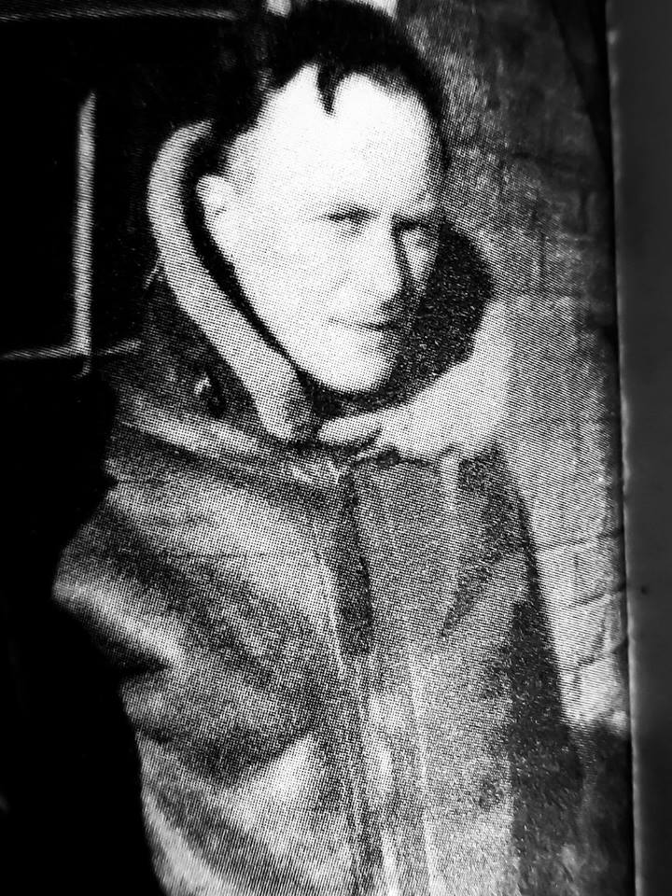
Guy Mayfield was educated at Lancing College and Magdalene College, Cambridge. Ordained in 1930 he was Curate St John's Fitzroy Square, and then St. Saviour's, Walton Street, both in the Diocese of London. His final curacy was at Hurstpierpoint. He was Assistant Editor of The Guardian (at that time known as The Manchester Guardian), 1936-39. In 1939 he joined that Royal Air Force Volunteer Reserve as a Chaplain. Following “training” (it was not very competently carried out) at RAF Cranwell, he was posted to the Air Ministry, specifically to the Headquarters of RAF Chaplaincy Services, in London, where his journalistic skills were fully employed in writing guidance notes for new Chaplains. He was then posted to RAF Duxford where he served throughout the Battle of Britain and where he wrote the diary that has recently been published as Life and Death in the Battle of Britain. He was at Duxford at the same time as Douglas Bader. After Duxford, Mayfield served in Gibraltar, Egypt and The Sudan. After the war he was Rector at St Paul's, St Leonards-on-Sea until 1946 and then Little Horsted until 1948. Like many military Chaplains, it seems that parish life was not for Guy for any extended period; he was Director of Religious Education in the Diocese of Chichester from 1948 and became Deputy Diocesan Secretary and Press Secretary in 1950. In 1956 he became Archdeacon of Hastings and Prebendary of Chichester Cathedral until he retired in 1975. He was also Select Preacher at Cambridge University. At some time during his time as Archdeacon of Hastings he was a Diocesan Director of Ordinands where he was responsible for the encouragement of the vocation of at least one future RAF Chaplain, Roger Kenward, who was to become an Assistant Chaplain-in-Chief in the 1980s. Obviously a born writer, between 1949 and 1965, in the midst of what must have been a busy ministry, he produced four books. He was Chairman of the College Council of Ardingly College from 1964 to 1972. Mayfield was married to Thelma and had two sons, Robert born in August 1940 at the height of the Battle of Britain, and Piers, born in September 1942. He was not well for the last few years of his life and he died in 1976 at the age of 71.

Published works
- An Anglican Guide to the Orthodox Liturgy. London: Fellowship of St. Alban and St. Sergius. 1949. OCLC 2679963. OL 21721570M.
- The Church of England: its members and its business. London: Oxford University Press. 1958. OCLC 752748288. OL 6241833M.
- Praying with Simplicity. London: Darton, Longman and Todd. 1964. OCLC 782994812. OL 19434779M.
- Like Nothing on Earth. London: Darton, Longman and Todd. 1965. OCLC 949043303. OL 18882353M.
- Life and Death in the Battle of Britain. London: Imperial War Museum. April 2018. ISBN 9781904897316. OCLC 991786414.

Stephen Ware (with a little help from Wikipedia)

