bibliography
(Compiled by Stephen ware)
January 2026

Charles R Benstead, Retreat, A Story of 1918, Methuen, 2018

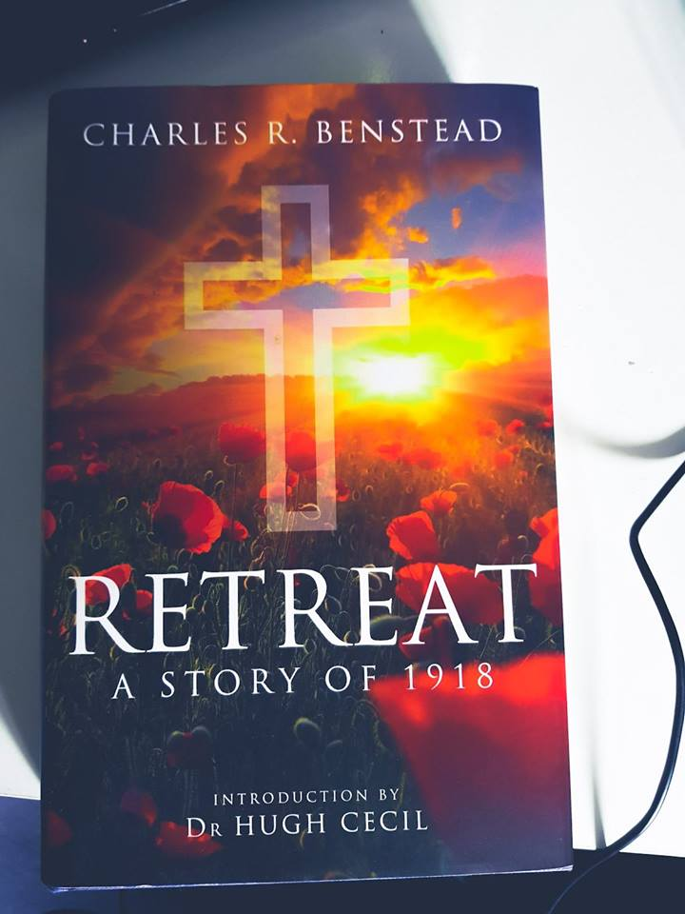
A novel, first published in 1930, written by an artillery officer describing the part played by an Anglican Army Chaplain of an Artillery Brigade during the German Spring Offensive of 1918. The Chaplain is new to military life and, although an experienced parochial clergyman, he is out of his depth in this new environment and is driven to despair by the impossibility of transferring his parochial model of ministry to the situation in which he finds himself on the Western Front. Benstead was sympathetic with religion, but the point of the book, it would appear, is to illustrate the absurdity of attempting to minister with formal religious beliefs and practices in war.

Joanna Bourke, An Intimate History of Killing, Granta Books 1999
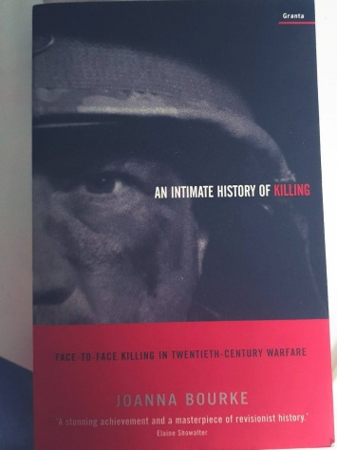
Although perhaps Joanna Bourke has an unhealthy and rather mawkish interest in death, dying and suffering, this is a well-researched study into what happens at the sharp end of war. Of particular interest are the chapters on War Crimes and Priests and Padres. The reflection on the role of Chaplains subsequent to the My Lai massacre in Vietnam gives pause for thought to any Chaplain who has responsibility for other Chaplains and to any Chaplain that is faced with military atrocity

Richard Collier, Eagle Day, J M Dent 1980

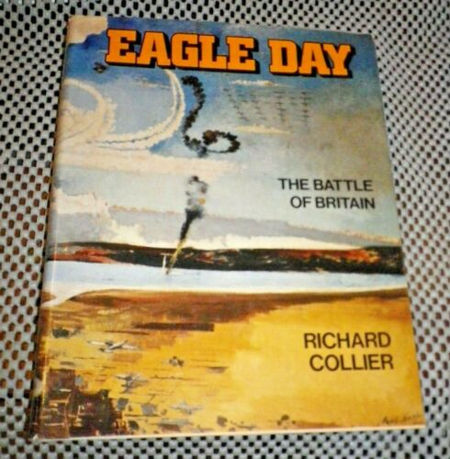
This could be described as a classic work about the Battle of Britain. First published in 1966 when it was possible to interview personnel who were actually there and took part in the events that took place during the summer of 1940. In many ways it reads like a novel and certainly does give insight into the thoughts, feelings and experiences of both military personnel and civilians, on both sides, at all levels of society.

Roald Dahl, Going Solo, Penguin Books 2018 (Part of the Penguin Centenary Collection)
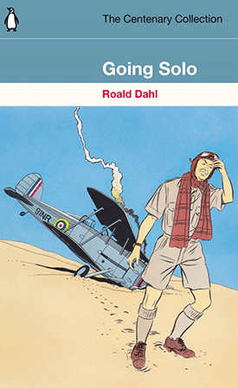
Roald Dahl’s account, first published in 1986, of his experiences in Africa, crashing an aeroplane in the Western Desert, rescue and recovery from his horrific injuries in Alexandria, and many other daring deeds, recreates a world as bizarre and unnerving as any he wrote about in his fiction.

Peter Fiennes, To War with God, Mainstream Publishing 2011
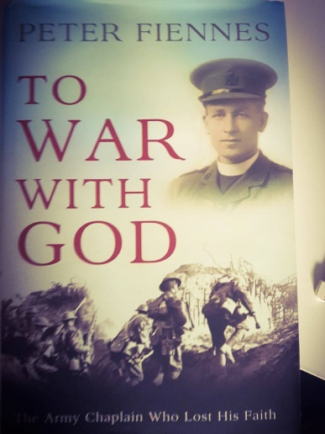
This is an account of the experiences of The Revd Edward Guilford as an Army Chaplain during the First World War. Peter Fiennes is “Monty” Guilford’s grandson and knew nothing about his grandfather’s experiences until he came across an old case full of papers. Monty never spoke about the war that came very close to destroying his faith and certainly transformed it. Thanks to Dick Sheppard at St Martin in the Fields Monty rediscovered, following his discharge from the Army, his sense of vocation to God (and explicitly God incarnate in Jesus) but not to the Church. This is a fine book that takes the reader along with what is, essentially, the author’s journey of discovery.

Atul Gawande, Being Mortal: Illness, Medicine and What Matters in the End, Wellcome Collection 2015
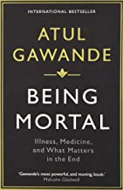
For most of human history, death was a common, ever-present possibility. It didn't matter whether you were five or fifty - every day was a roll of the dice. But now, as medical advances push the boundaries of survival further each year, we have become increasingly detached from the reality of being mortal. So here is a book about the modern experience of mortality - about what it's like to get old and die, how medicine has changed this and how it hasn't, where our ideas about death have gone wrong. With his trademark mix of perceptiveness and sensitivity, Atul Gawande outlines a story that crosses the globe, as he examines his experiences as a surgeon and those of his patients and family,and learns to accept the limits of what he can do. Never before has aging been such an important topic. The systems that we have put in place to manage our mortality are manifestly failing; but, as Gawande reveals, it doesn't have to be this way. The ultimate goal, after all, is not a good death, but a good life - all the way to the very end.
Recommended by Tony Fletcher

James Goodson, Tumult in the Clouds, Penguin Books 2018 (Part of the Penguin Centenary Collection)


Full of breathtaking descriptions of aerial dogfights as well as the stories of other aircrew colleagues, this book, originally published in 1983, is an ultimate story of War in the air, told by the one of the Second World War's outstanding fighter pilots. Although an American citizen, Goodson trained in Canada and served in the RAF as a member of 43 Squadron and then 416, the Eagle, Squadron (the American squadron of the RAF). After the US entered the War, Goodson joined the USAAF.

Mark Hammond, Immediate Response, Penguin Books 2018 (Part of the Penguin Centenary Collection)
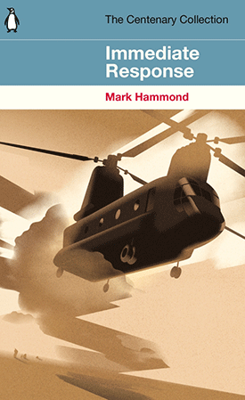
The gripping true story, first published in 2009, of a Royal Marine helicopter pilot on exchange with the RAF. Major Mark Hammond was awarded the DFC for remarkable feats in Afghanistan in his Chinook helicopter. Like the other Chinook pilots and crews, and the surgical teams who travelled with them, Hammond regularly put his own life in danger to save the lives of others.

Max Hastings, Chastise, Collins 2020
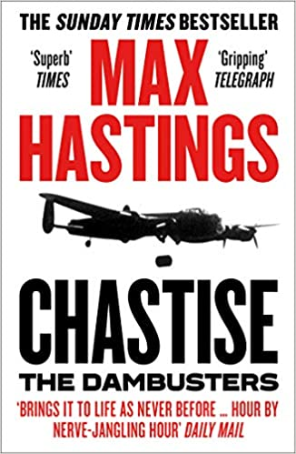

Operation Chastise was one of the most extraordinary episodes of the Second World War, yet it has also become one of the most misunderstood. Max Hastings tells the gripping story of the Dambusters raid, from the invention of the bouncing bomb to the moonlit cockpits of young pilots flying at treetop height through lethal enemy fire. But Hastings also challenges what we think we know about the Dambusters, bringing to light the difficult truths that have often been left out of the legend.
Recommended By Robin Noble

Richard Hillary, The Last Enemy, Penguin Books 2018 (Part of the Penguin Centenary Collection)
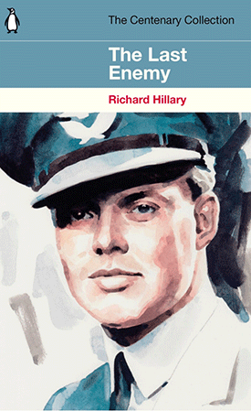
First published in 1942, just seven months before Hilary's untimely death in a second crash in a Blenheim after returning to flying following a first crash during the Battle of Britain during which he was dreadfully burned, this book has gone on to be hailed as one of the classic texts of World War II. Hillary’s injuries and treatment under McIndoe, the renowned pioneer of plastic surgery, led to him leaving behind what must have been intolerable egotism to a greater sense of responsibility for and fellowship with other human beings. It is a very thoughtful book.

Richard Holloway, Stories we tell Ourselves, Canongate Books 2020
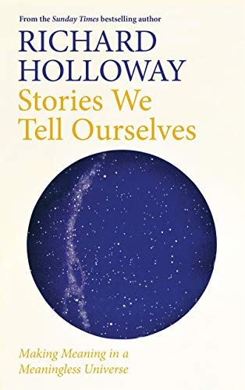
Throughout history we have told ourselves stories to try and make sense of what it all means: our place in a small corner of one of billions of galaxies, at the end of billions of years of existence. In this new book Richard Holloway takes us on a personal, scientific and philosophical journey to explore what he believes the answers to the biggest of questions are. He examines what we know about the universe into which - without any choice in the matter - we are propelled at birth and from which we are expelled at death, the stories we have told about where we come from, and the stories we tell to get through this muddling experience of life. Thought-provoking, revelatory, refreshing, compassionate and playful, Stories We Tell Ourselves is a personal reckoning with life's mysteries by one of the most important and beloved thinkers of our time.

Richard Holloway, Waiting for the Last Bus, Canongate Books 2018

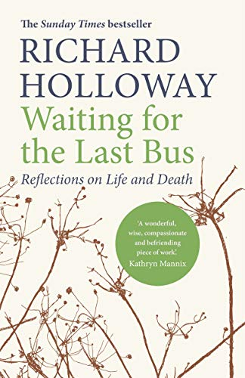
Where do we go when we die? Or is there nowhere to go? Is death something we can do or is it just something that happens to us? Now in his ninth decade, former Bishop of Edinburgh Richard Holloway has spent a lifetime at the bedsides of the dying, guiding countless men and women towards peaceful deaths. In The Last Bus, he presents a positive, meditative and profound exploration of the many important lessons we can learn from death: facing up to the limitations of our bodies as they falter, reflecting on our failings, and forgiving ourselves and others. But in a modern world increasingly wary of acknowledging mortality, The Last Bus is also a stirring plea to reacquaint ourselves with death. Facing and welcoming death gives us the chance to think about not only the meaning of our own life, but of life itself; and can mean the difference between ordinary sorrow and unbearable regret at the end.Radical, joyful and moving, The Last Bus is an invitation to reconsider life's greatest mystery.

Peter Lee, Reaper Force, John Blake 2018

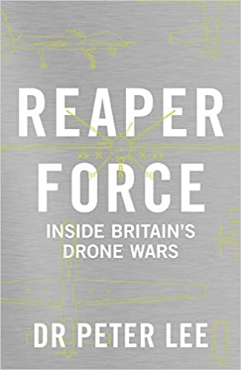
This unique insight into RAF Reaper operations in Afghanistan, Iraq and Syria is based on unprecedented research access to the Reaper squadrons and personnel at RAF Waddington in Lincolnshire and Creech Air Force Base in Nevada, USA. The author has observed lethal missile strikes against Islamic State jihadists in Syria and Iraq alongside the crews involved. He has also conducted extensive interviews with Reaper pilots, sensor operators, mission intelligence coordinators, and spouses and partners. The result is an intimate portrait of the human aspect of remote air warfare in the twenty-first century.

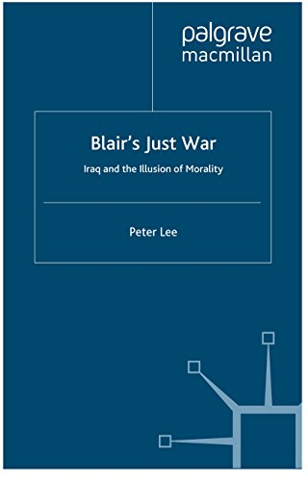
Peter Lee, Blair’s Just War, Palgrave 2011

Bringing together both contemporary and historical just war concepts, Peter Lee shows that Blair's illusion of morality evaporated quickly and irretrievably after the 2003 Iraq invasion because the ideas Blair relied upon were taken out of their historical context and applied in a global political system where they no longer hold sway.

Peter Lee, Truth Wars, Palgrave 2015

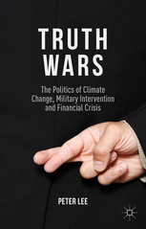
We live in an age of crises that are global in scale and potentially apocalyptic in severity, affecting the lives of millions billions of people. Peter Lee examines the struggle for truth at the heart of these crises to show how political leaders attempt to shape individual behaviour, attitudes and identity.

John Leonard and Philip Leonard-Johnson (Ed), The Fighting Padre, Letters from the Trenches 1915 – 1918 of Pat Leonard DSO, Pen ans Sword 2010

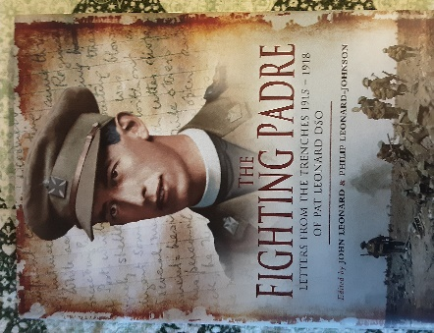
A collection of extracts from Pat Leonard’s letters written during his service as aChaplain to the Forces in France, Belgium and, after the Armistice, in Germany. Initially a Chaplain with the infantry, he was one of the first Chaplains to have a dedicated ministry to the Royal Flying Corps. In many letters to the relatives of his “parishioners” and to his parents he described the awful reality of life in the trenches, and, subsequently, life on makeshift RFC aerodromes which, despite the great danger of aerial combat “liberated his spirit” from the mud of Flanders. Later in th war, and after the war, Pat Leonard formed a close association with ‘Tubby’ Clayton and Toc H.

Brian Lucas, Reflections in a Chalice, Adastral Books 2011
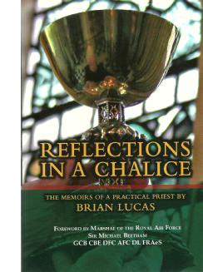
With many amusing anecdotes, this book takes the reader on a journey from the author’s childhood in a steel town in South Wales, through his time as a parish priest in the late 1960s, and then as a chaplain in the RAF in many parts of the world, and on to the period when he was the Chaplain-in-Chief of the RAF during the defence cuts in the early 1990s.

The latter part of the book covers the removal of the Iron Curtain and the emergence of Eastern Europe into an open democracy, his return to the parochial ministry and his eventual retirement in Lincolnshire.

Brian Lucas, Alive in Christ, Adastral Books 2020


In this volume, following an introductory essay on the Discipline of Preaching, Archdeacon Brian has selected, from a long ministry in the Anglican Church at home and overseas, sermons which he has delivered in a variety of times and places. Many are pastoral sermons on themes related to the Church’s year; others have a national context, including the First Gulf War, the Great Escape, the 75th Anniversary of the Chaplains’ Branch of the Royal Air Force, the Battle of Britain, the closure of the Princess of Wales Hospital, Ely, the 75th Anniversary of the Royal Air Force and the 50th Anniversary of the RAF Association, Brexit, the unveiling by Her Majesty The Queen Mother of a statue of Sir Arthur Harris in London, the South African Air Force, Remembrance Sunday, and the unveiling of the Coastal Command sculpture in Westminster Abbey by Her Majesty the Queen. Many who have heard them asked for a copy, and so this selection is published in the hope that in reading them the reader will be encouraged to be Alive in Christ.

Aidan McCarthy, A Doctor’s War, The Collins Press 2005
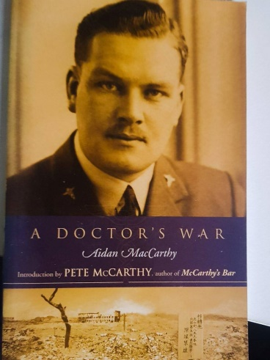
This is a profound memoir (first published in 1979) written by Aidan McCarthy on the suggestion of his doctors after he required brain surgery in the 1960s as a consequence of receiving repeated blows to his head from his Japanese captors when he was a POW. He ended the war in Nagasaki and witnessed the dropping of the atomic bomb. What starts as quite light hearted becomes more thoughtful and grave as it proceeds. McCarthy is convinced that it was his Christian faith that saved him.

Paul Marriner, The Blue Bench, Bluescale Publishing 2018

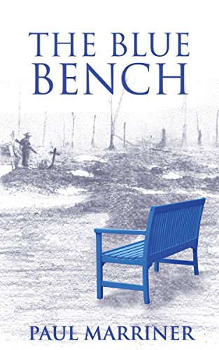
A beautifully written story of yearning and love in 1920 as a nation grieves - one soul, one person at a time. The body of the Unknown Warrior is coming home, can Britain find peace? The Great War is over but Britain mourns and its spirit is not yet mended. Edward and William have returned from the front as changed men. Together they have survived grotesque horrors and remain haunted by memories of comrades who did not come home. The summer season in Margate is a chance for them to rebuild their lives and reconcile the past Evelyn and Catherine are young women ready to live life to the full. Their independence has been hard won and, with little knowledge of the cost of thir freedom, they are ready to face new challenges side by side. Can they define their own future and open their hearts to the prospect of finding love? Will the summer of 1920 be a turning point for these new friends? As the body of the Unknown Warrior is returned, can the nation find a way forward? This novel, written in 2018, 98 years after the events that it describes, authentically portrays the atmosphere of the post World War One years and gives a true sense of the grief that was so universal at the time.

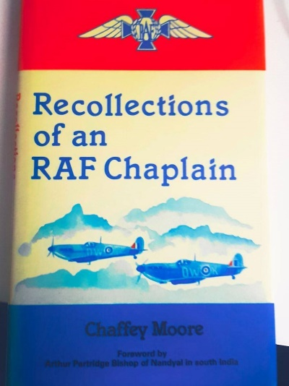
R G Chaffey- Moore, Recollections of an RAF Chaplain, The Book Guild 1988

R G Chaffey- Moore joined the RAF Chaplains’ Branch in 1942 and served in a number of locations both in the UK and overseas, including the Middle and Far East. At the end of the war he was in Burma where he contracted TB and spent two years in hospital in South Africa. On discharge he became the vicar of a parish in Dorset where he stayed for 30 years until retirement. This is a readable account of a very varied period of service and the impression that is given is that the author enjoyed being a RAF Chaplain very much. There are some very amusing anecdotes, some fascinating details of the life of a RAF Chaplain at this time, and also the recollection of some very serious experiences. Chaffey-Moore would have been a good man with whom to share a bottle.

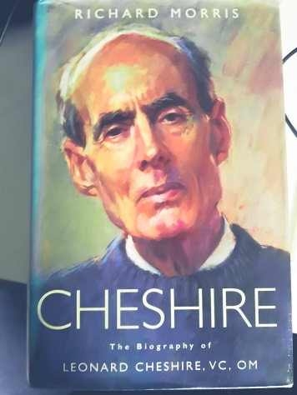
Richard Morris, Cheshire, Viking 2000

This is a fine, detailed and closely researched biography of an RAF hero, Leonard Cheshire, who won the VC for his leadership and operations during the Second World War Bomber Offensive and was an observer on the US atomic bomb mission to Japan in 1945. Following the war he became a committed Roman Catholic and founded the Cheshire Homes for the care of disabled people. He wrote, “The effect of all that I have witnessed, during World War II as well as since, has been to impress ever more deeply upon me the solidarity and interdependence of the entire human family”.

John Peters & John Nichol, Tornado Down, Penguin Books 2018 (Part of the Penguin Centenary Collection)
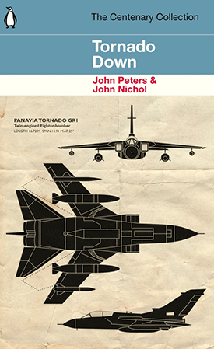
RAF Flight Lieutenants John Peters and John Nichol were shot down over enemy territory on their first mission of the Gulf War. Their capture in the desert, half a mile from their blazing Tornado bomber, began a nightmare seven-week ordeal of torture and interrogation which brought both men close to death. This book, first published in 1992, is a first hand account of these experiences.

P Hamilton Pollock, Wings on the Cross, A Padre with the RAF, Clonmore and Reynolds (Dublin)1954

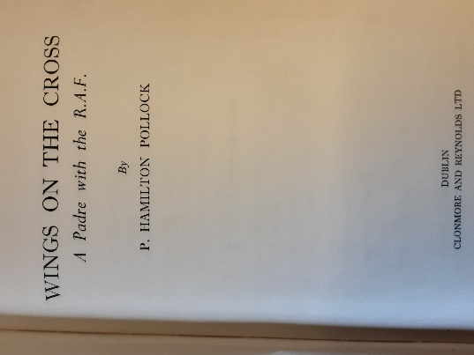
A Memoir written by an Irish Roman Catholic Dominican priest, who joined the RAF Chaplains’ Branch at the behest of his religious superior who was responding to a request from the RAF for Roman Catholic Chaplains in 1941. Throughout the book the author describes himself as Father Hamilton. Whilst in the UK he served on Coastal Command and Bomber Command stations before being posted to North Africa, Corsica, Sardinia and, finally, Italy. When in Italy he met Padre Pio. The style of this Memoir can only be described as old fashioned and quaint reflective of a time when Roman Catholic priests, and Roman Catholics, saw themselves as very distinct from other clergy, and other Christians; Father Hamilton would probably have viewed an interdenominational Branch with incomprehension. Nonetheless this is fascinating glimpse into the everyday life, with all its joys and tragedies, comradeships and friendships, of an RAF Chaplain in the Second World War.

Donald Wallace What a Wonderful World: Memories from an adventurous life well lived Fiona Tyson and Duncan Wallace 2025
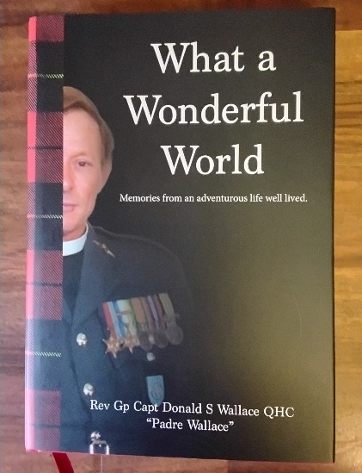
Padre Donald Wallace served as a Church of Scotland Chaplain in the RAF from 1951 until 1980 having served as a rating in the Royal Navy during the Second World War. Although published (in a very beautiful fashion) by his son and daughter, this book is entirely Wallace’s own words in which he describes and reflects upon a long life that included postings to the Middle East and Germany. He completed his RAF career as an Assistant Principal Chaplain. This is a memoir, based on the diary that Wallace maintained during his ministry, that provides an insight into what it was like to be a Chaplain during the Cold War and as the sun set on the British Empire, told with humour and honesty. He describes the memoir himself in these words, this is “….not the story of my life but just random memories and highlights of it, sometimes out of context, sometimes no doubt embellished and edited by the passage of time, and to ‘make a good story’. So forgive me.” It is a great deal more than that. Donald Wallace died in 2018 at the age of 92.

Stephen Ware, “Ministrare Non Ministrari” A History of Royal Air Force Chaplaincy, The Author 2025

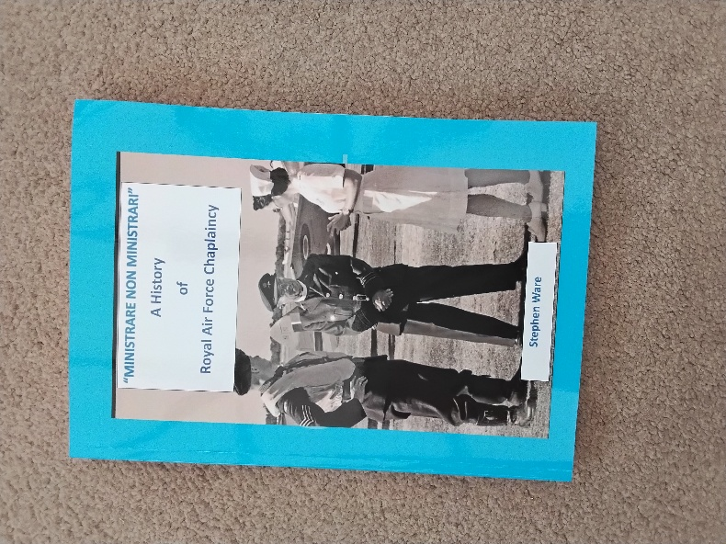
Until Stephen Ware compiled this book in 2025 there was, unlike the Army and the Royal Navy, no integrated history of Chaplaincy in the RAF. This book, comprising of words of Chaplains themselves over the course of RAF history together with reminiscences collected by the author spans the slightly more than a century of UK aviation Chaplaincy from the first Chaplains to the Royal Flying Corps to Chaplains who are currently serving in the Middle East. In due course many of these reminiscences and memoirs would have been lost, the books consulted, especially, were not re-printed and are, to a large extent, only to be found on the shelves of second hand bookshops. The author himself appears in the pages reflecting on his own experience over nearly 25 years, just under a quarter of the Chaplains’ Branch’s history, as a Chaplain in the RAF. Every Chaplain-in-Chief from 1918 to 2025 is referred and is illustrated with a photograph. The current Chaplain-in-Chief has written a Foreword.

Carl Warner (Editor), Life and Death in the Battle of Britain, Imperial War Museum 2018
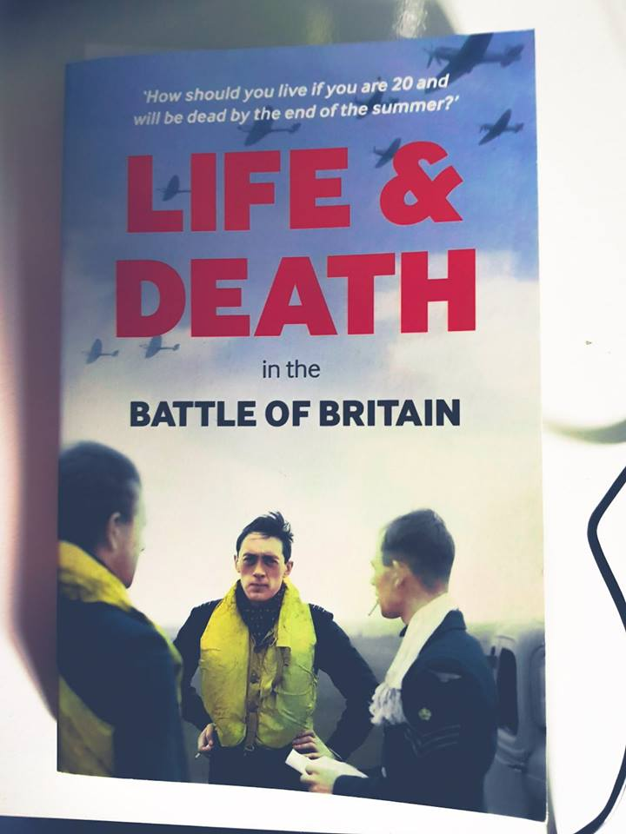
The diary of Guy Mayfield, who served as the Chaplain at RAF Duxford during the Battle of Britain. A fascinating glimpse of day to day life on an RAF Station in the summer of 1940, and an insight into conversations that took place between personnel, including pilots, and their Chaplain. There are some very moving episodes when Guy keenly feels the loss of friends; he developed very close relationships, especially with the aircrew, a demonstration that Chaplaincy is at its most effective when the Chaplain is fully involved in the lives of those with (rather than to) whom he ministers.

Geoffrey Wellum, First Light, Penguin Books 2018 (Part of the Penguin Centenary Collection)

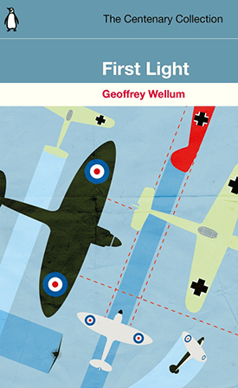
Two months before the outbreak of the Second World War, eighteen-year-old Geoffrey Wellum becomes a fighter pilot with the RAF... Desperate to get in the air, he makes it through basic training to become the youngest Spitfire pilot in the prestigious 92 Squadron. Thrust into combat almost immediately, Wellum finds himself flying several sorties a day, caught up in terrifying dogfights with German Me 109s. This is a finely written book , first published in 2003, that, apart from describing the life of a fighter pilot both during the Battle of Britain and subsequently during the battle for Malta (after which he suffered from severe batle fatigue), contains some highly evocative descriptions of flying. Wellum died in July 2018 at the age of 97, one of the last survivors of the Battle of Britain Association.

Janette Williams, First Lady of the Pulpit, The Book Guild 1993

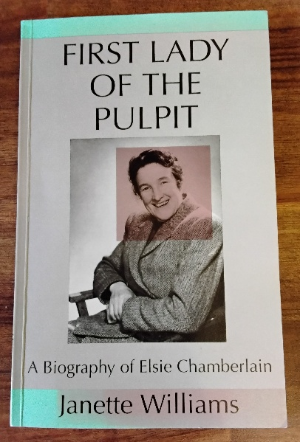
This is the biography of Elsie Chamberlain, a Congregational Minister and first female Chaplain in the UK Armed Forces, she served in the RAF Chaplains’ Branch. The biography has been compiled by Elsie’s adopted daughter from the papers that Elsie left behind and her own knowledge of her mother and father. The picture is painted of an immensely principled and brave woman who achieved a great deal in her life often in the face of opposition. The Church of England hierarchy does not emerge well in the text. On the cover page , the words of Dr Johnson are quoted when he said, “A woman’s preaching is like a dog’s walking on his hinder legs. It is not done well; but you are surprised to find it done at all”. Elsie Chamberlain spent her life, not only in the pulpit, but also on the parade square and the airwaves of the BBC, proving him wrong.

Gordon C Zahn, Chaplains in the RAF, Manchester University Press 1969
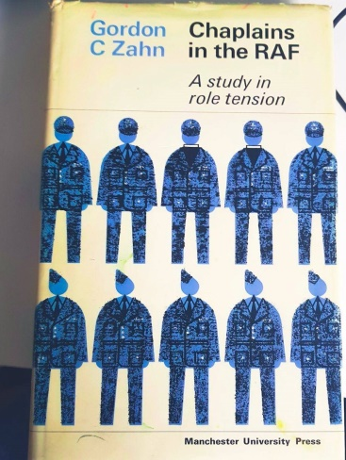
When this sociological study (Gordon Zahn was a professor of sociology both in the UK and the USA, and he was a pacifist) was published it was quite controversial as the RAF Chaplains who contributed to the research did so without authority from those higher up the RAF chain of command. Nonetheless it gives a fascinating insight into the thinking of RAF Chaplains in the 1960s on issues that are usually discussed in private if discussed at all. For those involved in ethical thinking with respect to the use of armed forces, this is a book that still has a relevance and a resonance.

IF YOU HAVE ANY SUGGESTIONS FOR ADDITIONS TO THIS BIBLIOGRAPHY PLEASE LET STEPHEN WARE, THE ADMINISTRATOR OF THE RAF CHAPLAINS’ ASSOCIATION WEBSITE, KNOW ON rafassn@btinternet.com.

