the reverend John hudghton

I spent six years in The Royal Air Force as a chaplain becoming a Royal Air Force Chaplain at the advanced age of 39yrs.

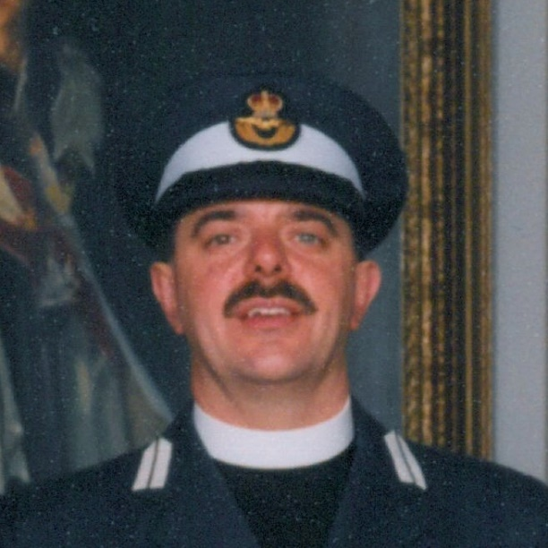
During my time in the RAF the so called “peace dividend” started to be cashed in, vast cuts in personnel and equipment started to take place and the British forces were being re-roled to be a force of deployment to defend our interests from other threats, much of it perceived as coming from the Middle East. However before I was to be personally involved in this scenario, I received notice after a very few months of being a Chaplain to Northern Ireland and almost as soon as my notice of deployment had “landed on my desk”, the troubles out there and on the UK mainland all heated up again. In 1996 the IRA bombed Docklands in London and The Arndale in Manchester (from which my family narrowly escaped) and a huge bombing of Hammersmith Bridge in London was attempted. Very soon I found myself serving in a very real zone of conflict.

My primary role of course was to bring pastoral care to RAF personnel through the whole of the province and to do the same for various army units to whom I was also assigned as Chaplain, particularly 9th Battalion The Royal Irish Regiment. This I did so and especially when Headquarters Northern Ireland was assaulted through two large IRA bombs leading to the death of a soldier and the serious injury of a number of personnel including the Senior Chaplain HQNI. The first bomb had been placed to destroy the vehicle checkpoint as many were leaving the site at the end of the day and the second was cynically placed between the medical centre and the chaplaincy to hit the wounded, those attending their wounds and those attending to the dead. I missed those blasts by 24hrs precisely.

However, I also understood that my task should also be that of helping to build peaceful and positive community relations. On the mainland Roman Catholic and “Protestant” personnel always worked together. Ecumenical relationships within the armed forces were good, perhaps even better than that of civilian mainland Britain as The Chaplain’s Branch of The RAF was an ecumenical outfit and a chaplain would see themselves as serving people of all faiths or none at all. Mix and match, sharing of church premises, plenty of joint activities were the order of the day, while of course each denomination retained its own particular integrities and necessary disciplines. So it was an affront to discover that when The Week of Prayer for Christian Unity came along that the local churches would invite the Protestant communities of RAF Aldergrove and not the Roman Catholic. I was pleased to say that I was able to argue the case effectively that our Roman Catholic brethren should be included (especially if they were putting their lives at risk for their freedom and security) and achieved a local milestone in understanding when the invitation was extended by the local churches to the Roman Catholic community as well. Reconciliation was an essential part of Christ’s ministry, reconciling the world to God and humanity to each other and I understood Christian ministry as extending Christ’s ministry of reconciliation in this day and age. It was a drop in the Ocean, but the Ocean is merely many drops of water.

Sometimes reconciliation occurred through much less purposed means. A Soldier from The Royal Irish Regiment approached me as Chaplain to arrange a wedding. This was unusual and he needed my help. He was from one side of the divided nation, a Protestant with some past membership of the Orange Order and The Black Preceptory (extreme expressions of Protestantism) to his name. He had fallen in love with a girl who was a Roman Catholic who originated from the Ardoyne, a hotbed of Irish Nationalism in Belfast. Having mutually discovered that the other did not have three heads or horns, they now wanted to take the risky step of marriage, even though it might attract hostility from both communities. The power of love had wonderfully made a bridgehead reconciling something of the divide of two opposing powers. I was privileged to be the Priest to minister to them and enable the neutral and comparatively safe ground of a Chaplaincy at Aldergrove for their celebration, though this caused our security services an absolute nightmare in policing and checking security clearances. I had nightmare visions of the possibility of having to keep two factions apart, but all went smoothly and I have no doubt that bringing on board an enlightened Roman Catholic Priest to assist with prayers was a helpful factor in all of this.

The story though developed. About a year later, a baby and a baptism from the couple took place at RAF Aldergrove. Again it was a wonderful celebration; some thought that the baby should have been baptised either Roman Catholic or Protestant but most guests were happy that the baby was being baptised at all and that The Church of England being a somewhat broader church, particularly in the chaplaincy model, was a good compromise. Two communities normally divided, found themselves meeting, through the love of a couple and in holy worship. I wished the story had ended there, but sadly it didn’t as a fortnight afterwards the child died through “cot-death” and a funeral had to be arranged. Again with a remarkably talented Roman Catholic Priest from the Ardoyne, we arranged a service, but this time from the family home and on the neutral ground of a graveside. I witnessed Catholic and Protestant joining together through the bitterness of grief and a genuine sense of community support to two extremely bereft parents. We sung together, prayed together and wept together but I am convinced that this series of events, more than any other I personally witnessed in Northern Ireland, brought a deeper sense of acceptance, reconciliation, peace and understanding to a small section of two divided and hostile communities.

By The Revd (Sqn Ldr (rtd)) John Hudghton

