the falklands war – ten years on

by Ian Greenhalgh

In January 1992 the Chaplain-in-Chief Brian Lucas asked me to meet him at Adastral House (the location of the Headquarters of RAF Chaplaincy Services); I wondered if I was in trouble, but Brian asked me if I would go to The Falklands in April 1992 until September. I flew from Brize Norton in Spring, arriving in The Falklands as they began their winter.

I was also informed by Brian that it was the 10th Anniversary of the liberation of The Falklands and as a result there would be many memorials and special services to celebrate the freedom that the island now had.

I hit the ground ‘running’ and those first weeks truly were amazing and non-stop. There were Memorials in all the important locations; helicopters took me around to the more distant and less easily accessible places like Goose Green.

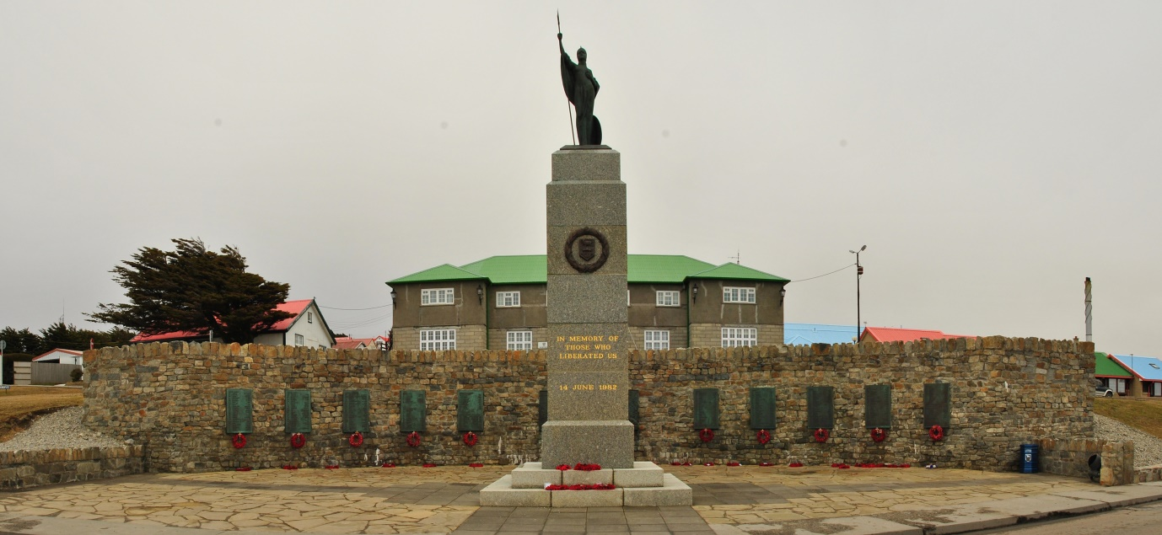

The Falklands War Memorial Stanley

All the major military senior officers who had been involved in the conflict in 1982 came to the Falklands that spring. Mrs Thatcher and Dennis Thatcher also came for the service of thanksgiving in Stanley. I even had the honour of preaching to Mrs Thatcher at one of the services.

I met some of the Paras who had been involved in re-taking Goose Green during the memorial service there; they had come down especially to remember some of their friends who had been killed. One of the Paras said he thought the doctor who was with them was the one who later suffered the most with PTSD. 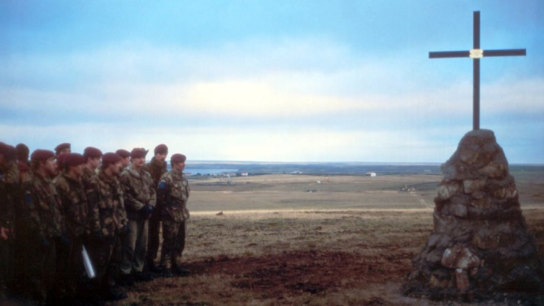

Memorial at Goose Green

All those services, the range of people that I met, both locals and service personnel, were both a real privilege and honour and one of the highlights of my ministry. I had some very sad duties to fulfil, for example committing the ashes of a father whose son had been killed when Sir Galahad sank; his wife came and we went out to the spot to commit the ashes, as I took that short service News at 10 filmed the event.

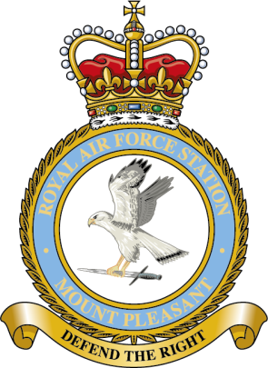One morning at Mount Pleasant Airfield (the large base built by the RAF following the conflict some 27 miles or so from Stanley) a box came in the post addressed to The Force Chaplain; in it was a poppy wreath and 22 small wooden crosses with a letter attached. The letter came from a widow of one of the soldiers killed in the final battle; she said, “Padre could you go with some of the soldiers from my husband’s regiment and lay the wreath, place the 22 crosses, and say the appropriate prayers. When my husband died I was 7 months pregnant, my son is nearly 10 now”.

I had one particularly memorable Sunday. I had an early breakfast and then took the service at Mount Pleasant in the Chapel. I then got in my Land Rover and drove to the helipad, from where I was flown out to sea and was landed on a Royal Naval ship which I recall was HMS Liverpool. I took  their morning worship, had coffee and then flew to Mount Alice, one of the radar sites. The helicopter flew off and I then took a service and joined 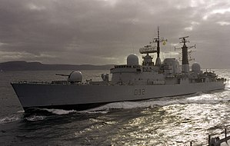everyone for Sunday lunch. Around 2.30pm I was collected again and flown to Stanley; I enjoyed afternoon tea and then I preached at Evensong in the Cathedral, spoke at the Tabernacle Chapel to a group of young people, and, having collected my Land Rover, which someone had driven from Mount Pleasant, I drove back the hour long journey to MPA. I finished the day with a beer in the mess!

HMS Liverpool

My time in the Falkland went so quickly, I met some lovely people and felt honoured to have served God in such an amazing place.