the reverend Stanley William Harrison

The citations below are for the award of a George Medal (this medal was instituted on 24 September 1940 by [King George VI](https://en.wikipedia.org/wiki/George_VI_of_the_United_Kingdom) is a decoration of the [United Kingdom](https://en.wikipedia.org/wiki/United_Kingdom) and [Commonwealth](https://en.wikipedia.org/wiki/Commonwealth_of_Nations), awarded for [gallantry](https://en.wikipedia.org/wiki/Courage) "[not in the face of the enemy](https://en.wikipedia.org/wiki/Non-combatant)" where the services were not so outstanding as to merit the [George Cross](https://en.wikipedia.org/wiki/George_Cross)) and an Order of the British Empire to The Reverend Stanley William Harrison for two acts of bravery.

The first instance, for which Harrison was awarded the George Medal, took place at RAF Stradishall in Suffolk. Wellington T2841/BU-K of 214 Squadron piloted by Flight Sergeant ‘Johnnie’ Smiles took off from Stradishall to attack Wilhelmshaven just after 3 am on 30 January 1941. As the aeroplane took off, the port engine failed and the fully laden bomber flopped back down on to the runway and burst into flames. Stanley Harrison was one of the first on the scene and was instrumental in getting Johnnie and two of his crew out before they could suffer serious injury. Two other crew members were buried under the wreckage and died.

Johnnie Smiles was subsequently posted from Stradishall to 21 Operational Training Unit at Moreton-in-Marsh as an instructor and was injured in an accident on 16 June 1941. Later in the war he was commissioned but nothing is known of his further wartime career.

O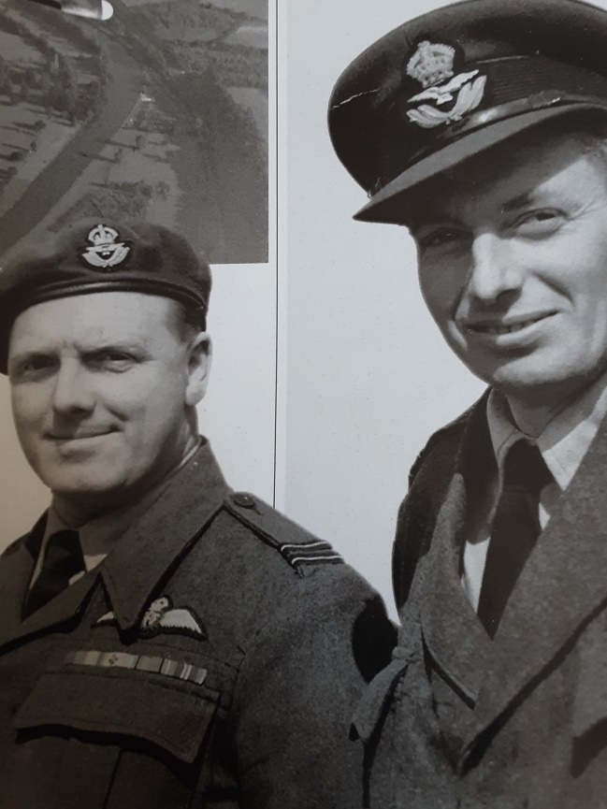n 25 April 1955 Smiles was serving with No 2 Air Navigation School as a Vickers Varsity pilot when he was involved in a strange and ultimately tragic incident. Early in the evening at RAF Thorney Island near Chichester, Leading Aircraftsman Nanik ‘Nick’ Agnani, a ground crew member who’s poor eyesight had prevented him from being a pilot, started up Varsity T.1 WF246 and began taxying out. Agnani had had some private flying lessons and , despite the efforts of Air Traffic Control, managed to take off. Two Varsitys, one piloted by Johnnie Smiles and the other by Flight Lieutenant Peter Jones, gave chase. They attempted to shepherd Agnani to land and they also tried to make radio contact with him; in both they were unsuccessful. Agnani circled the airfield several times and then headed towards Chichester and Brighton at low level with the other two aircraft providing an escort. From Brighton Agnani headed towards Hornchurch in Essex and then turned west over central London, at times descending to 200ft. By this time the light was fading and the pursuing aircraft lost visual contact, the last siting was by Smiles at 9.05pm. As Agnani was flying so low, it was difficult to keep track of him with radar, and , in the end he crossed the Channel and crashed into a farmhouse at Onnaing near Valenciennes. Agnani was killed as were three French civilians[1].

Flt Lts Peter Jones and Humphrey "Johnnie" Smiles DFM (right). The pursuing Varsity pilots.

It’s interesting to note that, given that the date of Padre Harrison’s second decorated act of bravery was 1957 and Flt Lt Smiles involvement in the rogue Varsity incident was 1955, both men would have been serving in the RAF a considerable number of years after the ending of World War Two; it would be good to know if the two men remained in touch – after all one saved the other’s life.



1. Information on this incident obtained from Chris Goss, *Date with Disaster*, Article in *Britain at War* magazine, March 2020.