Sergeant john haire
(1920 – 1940)

This is the story of Sergeant John Haire; I came across his story some thirty years ago, around the time of the 50th Anniversary of the Battle, when I was on holiday on the Isle of Wight.
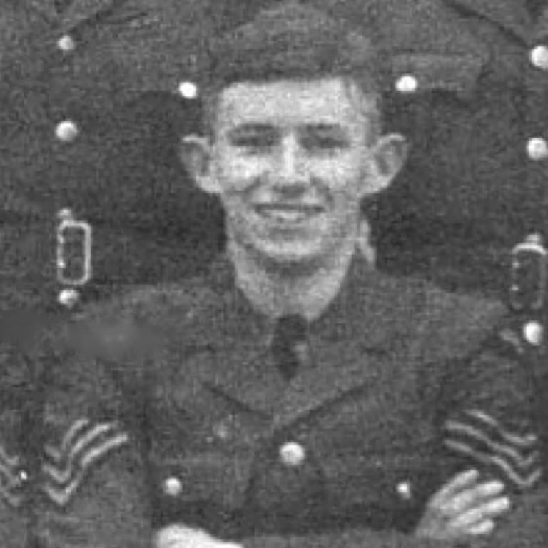
Sergeant Haire is not one of the big names of the Battle of Britain, he was not decorated for bravery, but he was one of “The Few” and he did make the ultimate sacrifice. John Haire was, as ACM Sir Christopher Foxley-Norris described, alongside all those who served in the Battle: “… no Galahad, no knight sans peur et sans reproche. Sans Peur? Fear was the second enemy to beat. He was a common, unconsidered man, who for a moment of eternity held the whole future of mankind in his two sweating palms. And did not let go. Remember him, not as he is portrayed, but as he was. To him you owe most of what you have and love today.”
John Haire was born in September 1920 (meaning that he was 20 years old when he fought in the Battle of Britain) in Belfast. When he left school in 1938, he became a Civil Servant and joined the RAFVR in the summer of 1939. On completion of his flying training, in September 1940, he was posted to RAF Dyce, near Aberdeen, to fly Hurricanes with 145 Squadron. In October the Squadron, with Sgt John Haire, moved south to RAF Tangmere. He participated in a number of relatively uneventful patrols until, on 23 October, over Beachy Head, he and another pilot attacked a German Junkers Ju88 that eventually crashed in northern France.
On Sunday 27 October in the late afternoon 145 Squadron was scrambled to patrol east of the Isle of Wight as both Southampton and Portsmouth had been bombed. Almost immediately they were engaged in dogfights with ME109s over the Island. Several of the Hurricanes were shot down including Sgt Haire who crashed a short way out from the beach at Bembridge. The local coastguard, Leonard Rowe, had seen him fly low over the cliffs with smoke coming from his engine and crash landing in the water. Rowe went to help him ashore but John Haire insisted on salvaging the radio from the aircraft before he took any notice of himself and before the Hurricane sank. He then went back to the coastguard’s home where he was given meal and a bath and where the Rowe’s wife dried out his uniform. In a letter that he wrote to John Haire’s parents, Rowe said, “My wife dried out his clothes ready for the next morning and mothered him during his brief stay with us. We talked very little, only of his home in Belfast and his rides on his motor bike along with another chum. He was a fine lad, not at any time did he think of himself and was afraid of being a trouble to others. For our part we have been proud to have been of service and grateful to one of them who have gallantly given their lives to save our homes. God bless them.” The finality of this letter is because just 10 days later John Haire died.
It was on 6 November (technically after the official end of the Battle) when John Haire with 145 Squadron and 602 Squadron engaged Me109s between the Isle of Wight and Shoreham. Several 145 Squadron Hurricanes were hit including that of John Haire. What happened was observed by the ARP post near Arreton on the Isle of Wight; the wardens saw Sgt Haire’s Hurricane engulfed in flames diving towards the village of Arreton. Instead of bailing out he remained at the controls in order to steer the aircraft away from the houses of the village and not until he had done so did he attempt to bail out; however by this time he was too low and his parachute didn’t open fully so that he died shortly after impacting with the ground a short way from where his aircraft crashed. The local vicar, The Revd Edward Burbidge wrote to Sgt Haire’s commanding officer these words, “I understand that a pilot named Haire who crashed and was killed near here about 3pm today came from your command. I managed to reach the spot just before he died. He had apparently jumped when near the ground as he was lying some distance from his plane. He never regained consciousness, but I was able to say a commendatory prayer and give him the Blessing as he died. The men around joined in the Lord’s Prayer. We cannot but feel grateful to him for bringing his machine down clear of our village. Perhaps it may be of some comfort to his relatives if you could pass some of this on.”
Sometimes the events of history require extraordinary deeds from very ordinary people.

In friendship and in service one to another we are pledged to keep alive the memory of those of all nations who have died in the Royal Air Force and in the Air Forces of the Commonwealth in the Battle of Britain. In their name we give ourselves to the cause of justice, peace and love. Proudly and thankfully, we will remember them. Amen

Stephen Ware
August 2024

