THE RIGHT REVEREND JOHN JAGOE (1889 – 1962)

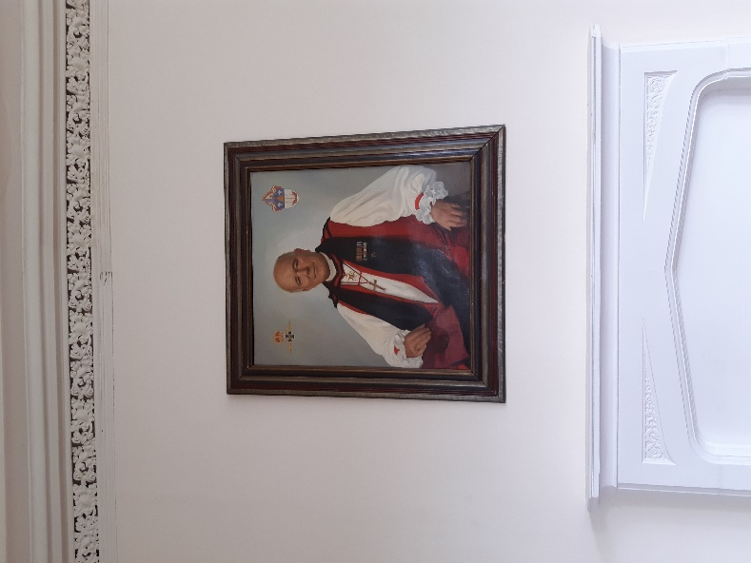

John Arthur Jagoe was born on 2 January 1889 in Ireland. He was educated at Trinity College, Dublin and was ordained in 1912.

During the First World War he served as a Chaplain in the Royal Army Chaplain’s Department and remained as an Army Chaplain until he transferred to the Royal Air Force Chaplains’ Branch on 23 October 1923. He was granted a permanent commission on 6 July 1927 and then was promoted to the relative rank of Group Captain on 6 March 1938.

In 1919, he married Janet Flewett, the daughter of William Flewett the 8th Bishop of Cork, Cloyne and Ross. They had no children.
He was appointed Assistant Chaplain-in-Chief in 1939. On 10 April 1944, he was granted the relative rank of air commodore and was appointed Chaplain-in-Chief. He was granted the relative rank of air vice-marshal on 1 July 1946.] He was succeeded in the appointment of Chaplain-in-Chief by Leslie Wright on 31 March 1949. He retired from the Royal Air Force on 26 May 1949.
Padre Jagoe was appointed Honorary Chaplain to the King on 30 January 1943.] He vacated the appointment on 26 May 1949. In the 1946 King's Birthday Honours, he was appointed Commander of the Order of the British Empire (CBE). In the 1949 New Year Honours, he was appointed Companion of the Order of the Bath (CB).
On 18 November 1947, he was awarded the Czechoslovak Republic's Medal of Merit (1st Class) "in recognition of valuable services rendered in connection with the war".
He was appointed to the colonial Episcopate as Bishop of Bermuda following his retirement from the Royal Air Force. He was consecrated bishop by Geoffrey Fisher, Archbishop of Canterbury, on Candlemas (2 February) 1949 at Westminster Abbey. Brian Lucas has written the following, “I remember Hewitt [Wilson, Chaplain-in-Chief 1973 – 1980] telling me that on his appointment John Jagoe protested to the Archbishop. “Your Grace, there must be far more able men than I”, only to hear the Archbishop reply, “There are, Jagoe, but I have other jobs for them.”” He held the post to 1955 when he resigned on grounds of ill-health.
From 1956 to his death, he was Rector of Schull, County Cork, Ireland. June Sirr has written, “When I was a child Bishop Jagoe, having retired from Bermuda , became rector of Schull Parish in West Cork. He was loved by all. I have memories of him walking down Schull Main Street in his Bishop’s Cassock! He is buried in our local graveyard and there is a Memorial Plaque to him in Holy Trinity Parish Church, Schull.” Bishop Jagoe died on 16 October 1962.
The portrait above, showing Padre Jagoes in his episcopal robes, hangs in the Armed Forces’ Chaplaincy Centre at Beckett House, Shrivenham. The crest on the left is that of the RAF Chaplains’ Branch and that on the right is that of the Diocese of Bermuda, as John Hetherington has observed, “the white flowers on the crest, are Lilies as seen on the Diocese of Bermuda Crest. Although these lilies bear the botanical name 'Lilium Longiflorum, they are also known by several other names from 'Trumpet Lily' to ‘White American’, but they are also known as the ‘Bermuda Lily’.”

