the right reverend Len Ashton (1915 -2001)

Early life and education
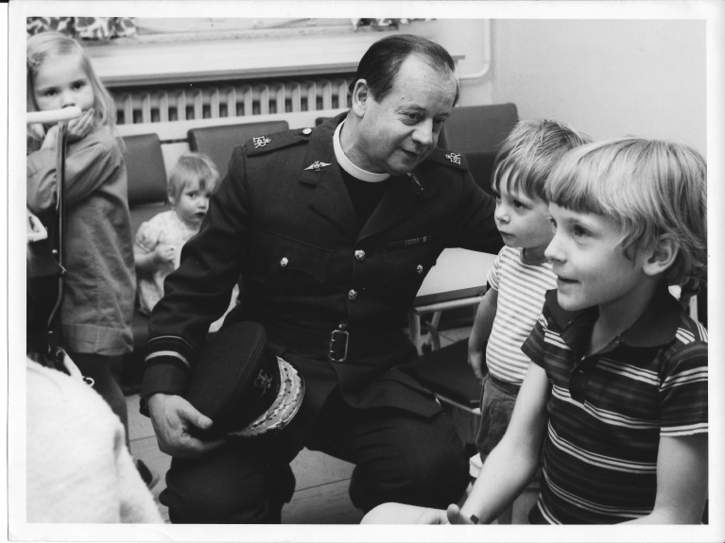
Len Ashton visiting the RAF Hospital at Wegberg
Leonard (Len) Ashton was born on 27 June 1915 to Henry Ashton and Sarah Ashton (née Ing). From 1940 to 1942, he trained for ordained ministry at Tyndale Hall, Bristol, an evangelical Anglican theological college.

Early ministry

Len was ordained in the Church of England as a Deacon in 1942 and as a Priest in 1943. From 1942 to 1945, he served his curacy in Cheadle in the Diocese of Chester.

Military service

On 15 May 1945, Len was granted an emergency commission in the Chaplains Branch of the Royal Air Force and granted the relative rank of Squadron Leader. He served in North Wales during 1945, before being posted to Air Headquarters Malaya and Singapore in 1946. The story goes that when he arrived on his first station, having been told to report to the Adjutant, he was met by the Chaplain there at the gate who he told that he needed to see the Adjutant. The Chaplain replied that he’d take him to the Mess and that he could see the Adjutant the next day. Len subsequently reflected that this taught him, at this very early stage in his RAF career, that the Adjutant was someone who could be seen tomorrow. From 1947 to 1948, he served in Japan. In 1948, he returned to the United Kingdom and was posted to RAF Halton in Buckinghamshire. On 4 May 1949, he was granted a short service commission in the relative rank of Squadron Leader with seniority from 15 May 1945. From 1949 to 1950, he served at RAF Feltwell in Norfolk.

Len was transferred to a permanent commission on 21 June 1950. From 1950 to 1953, he served as a lecturer and Chaplain at the RAF Chaplaincy School located at Dowdeswell Court near Cheltenham, Gloucestershire. From 1953 to 1954, he was posted to Air Headquarters Iraq. From 1954 to 1960, he served at RAF College, Cranwell, the Royal Air Force's main officer training establishment. On 15 May 1959, he was promoted to the relative rank of Wing Commander. From 1960 to 1961, he once more served abroad having been assigned to British Forces Arabian Peninsula and Middle East Command.
In 1962, Len returned to England and was promoted to Assistant Chaplain-in-Chief. From 1962 to 1965, he served at Headquarters, RAF Training Command. From 1965 to 1969, he was the Resident Chaplain (i.e. priest-in-charge) of St Clement Danes in London, the Central Church of the Royal Air Force. In 1969, he was appointed Chaplain-in-Chief of the RAF and promoted to the relative rank of Air Vice-Marshal. As the most senior Anglican Chaplain, he was also appointed Archdeacon for the Royal Air Force in the Church of England.

Robin Turner remembers being interviewed by Len to become a Chaplain, “My other memory is of the day I was interviewed for the Branch. I was exploring RAF Chaplaincy as a possible “second curacy” and was invited to Adastral House for what was billed as an “informal chat” though I was aware that this was actually an interview. I first saw the then Staff Chaplain, Allan Vickers, who spent quite a lot of the time asking whether I was prepared for the possibility of a 13-month unaccompanied tour on Gan or some such place. As he then ushered me into the presence of the Chaplain-in-Chief he whispered to me “by the way, he ranks as an Archdeacon in the Church and an Air Vice-Marshal in the RAF.” I was, as a pale young curate from Devon, immensely impressed by this. The invitation was in December 1969 and included an invitation after the informal chat to a Carol Service in St Clement Danes and lunch in a pub. As the chat drew to a close I saw that it had begun to snow. Eventually Allan Vickers came round to the office and said we needed to be moving down to SCD. As we walked through Adastral House the discussion was whether we should walk or ride down Kingsway. It was decided that we should ride and I envisaged a staff car to waft this senior office down to the church waiting outside the door. No such luck, we went on the bus and as we travelled it was decided that the Staff Chaplain would pay the bus fares and the Chief would pay for the lunch. All this happened and at the end of the lunch in a pub near SCD I can still see Len getting down off his bar-stool and saying to me, ‘I think we’d like you to join, the Staff Chaplain will send you the papers.’ Thus began 28½ super years as a member of the family of the Chaplains’ Branch, though when I became Chaplain-in-Chief we did tighten up the recruitment and interview procedures!

When we were at RAF Nicosia he lived just round the corner from us in the MQs and, as a bachelor, when he as in residence, spent many an evening round at our house. He also said to me as far as the station chaplaincy was concerned “regard me as your curate” and he was willing, whenever he was in Nicosia, to help in the Station Church of St Columba. An interesting dynamic for an almost brand new chaplain!”

After nearly 30 years serving in the Royal Air Force as a Chaplain, Len retired from the military in 1973.

Episcopal ministry

In 1974, Len was consecrated a Bishop. From 1974 to 1976, he served as an Assistant Bishop in the Diocese of Jerusalem. In 1976, the Anglican presence in the region was reorganised, this resulted in the creation of the Episcopal Church in Jerusalem and the Middle East and four new dioceses. One of these new dioceses was the Diocese of Cyprus and the Gulf, and Len was appointed its first diocesan Bishop. He was also an Episcopal Canon of St George's Cathedral, Jerusalem from 1976 to 1983. There is a story of when he first arrived in Cyprus in 1974. As there was no Bishop’s house provided he, presumably owing to his RAF connections, was given a RAF married quarter to live in at what had been RAF Nicosia. The Chaplain there at the time was Robin Turner (who was Chaplain-in-Chief 1995 – 1998) and it is who tells this story. He was a neighbour of Len and recalls the day that the Turkish forces invaded on 20 July 1974. It was quite a dangerous situation and Robin was put in charge of the Station Medical Centre as the doctor, a local Cypriot, could not get in to work. It was a tense day with a great deal of uncertainty; the British forces were quite vulnerable and Robin remembers there being an amount of shelling. However, in the midst of all this, Len was seen walking down the married quarter road asking anyone that he met whether they had any tonic to go with his gin! s, Robin subsequently reflects, “ He spent quite a lot of that day with my wife and two small boys, then aged 6 and 2, playing games in the central corridor of our bungalow helping to keep the boys’ minds off the noise of the bombs. A possible rider to this is that on the evening of 20th July 1974, the day of the invasion, +Len and I went round a lot of the MQs in RAF Nicosia visiting personnel and families who were pretty traumatised by a day of bombing. His presence was calm and reassuring and for me, as a pretty new chaplain who had spent the day under fire, he seemed to take it all in his stride; very little seemed to faze him!” When somebody has been in Japan in the aftermath of atomic bomb explosions it is probable that very little will cause that person to panic. Len served as Bishop of Cyprus and the Gulf from 1976 until he retired from full-time ordained ministry in 1983, and was succeeded by Henry Moore as Bishop.

With retirement, Len returned to the United Kingdom and was appointed an honorary Assistant Bishop of the Diocese of Oxford. He died on 19 January 2001 in Chesham, Buckinghamshire. His memorial service was held at St Clement Danes, the address on this occasion was given by Robin Turner, who has added some of his memories of Len to this biography.

In the 1970 New Year Honours, Ashton was appointed Companion of the Order of the Bath (CB).

Mike Roemmele (a RAF Chaplain from 1983 to 1999) writes :

“Len Ashton played a significant role in my life and in my ministry.

Between 1979 - 1983 I was serving in Bahrain ( Diocese of Cyprus and the Gulf) as a civilian Chaplain under the auspices of J& MECA (Jerusalem and Middle East Church Association) when he was the first Bishop in the recently established Anglican Diocese of Cyprus and the Gulf . He was largely influential in developing the structure of the Anglican Church in Cyprus and the Gulf States and its ministry to the expatriate communities of the Middle East with a team of Chaplains in each state.

He established two Archdeaconries, each with a cathedral, one in Nicosia and the other in Bahrain to oversee his ministry and travelled extensively to visit all his congregations every year. He was well known and highly regarded throughout the Middle East as a statesman and an eccesiastical dignitary by many of the rulers in the Gulf States and also by the civil authorities and the Orthodox church leaders in Cyprus. It was a region he had come to know well when serving as an RAF Chaplain, and particularly at the time when Cyprus was divided.

Having spent 4 years in his Diocese, I felt that it was time for me to look towards a new chapter in my ministry and Bishop Len encouraged me to consider a possible calling to chaplaincy in HM Forces.

With his encouragement in 1983, I was commissioned as a Royal Air Force Chaplain”.

